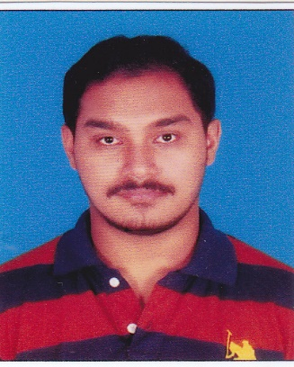**Mrinmoy Kumar Das**

**Phone:** 7358336050

**Address:** SMQ 316/1, Madambakkam Camp, Air Force Station, Tambaram, Chennai - 600073

**Email:** [mrinmaykumardas@gmail.com](mailto:mrinmaykumardas@gmail.com)

**Carrier Objective**

*To enhance my working capacities, professional skills, efficiencies. I would like to combine my passion for learning my development skills to continue building personalized learning products for people.*



**EDUCATION**





|  |  |  |  |  |
| --- | --- | --- | --- | --- |
| S. No | Qualification | Institution | CGPA/Percentage | Duration |
| 1. | Bachelor of Technology | SRM Institute of Science and Technology, Ramapuram, Chennai - 60089 | 9.07 | 2015 – Present |
| 2. | HSC | Kendriya Vidyalaya No 2, AFS Tambaram, Chennai – 600073 | 88% | 2014 – 2015 |
| 3. | SSLC | Kendriya Vidyalaya, AFS Begumpet, Hyderabad - 500011 | 9.4 | 2013 - 2014 |

**SKILLS**



C



C++



Java



Android Development



Web Development



PHP



Microsoft Office



**PUBLICATIONS**



**1. Pocket Study**

International Journal of Advance Research and Innovative Ideas in Education *(IJARIIE-ISSN(O)-2395-4396),* Paper Id - 6714

*19 October 2017*



**2. IP Based Device Control**

International Journal of Advance Research and Innovative Ideas in Education *(IJARIIE-ISSN(O)-2395-4396)*, Paper Id - 7832

*03 April 2018*



**MINOR PROJECT**

**1. Pocket Study (July 2017 – October 2017)**

It's an android application which focuses on relieving the difficulties for the college students by providing the supporting materials for their curriculum.

**2. IP Based Device Control (January 2018 – April 2018)**

IEEE Paper of Multi-Disciplinary Design Concept for a Home Automation System using the Internet of Things

**SOFTWARE PROFICIENCY**



Android Studio



MS Office



Eclipse



Adobe Dreamweaver



Atom



Cisco Packet Tracer



**LANGUAGES**



* **English** (Professional Working Proficiency)
* **Hindi** (Professional Working Proficiency)
* **Assamese** (Professional Working Proficiency)

**ACHIEVEMENTS**

Certification on Database Management Systems from NPTEL (February 2018 – April 2018)



Participated in Hackathon conducted by SRM Axis Intellects Pvt Ltd. (24th March 2018)



Participated in Hackathon conducted by Hindustan University, Chennai (4th August 2017 – 5th August 2017)

Industrial Visit in Doordarshan Kendra, Chennai (20th March 2017)

Industrial Visit in BSNL, Chennai (27th September 2016)



In plant Training in Airport Authority of India, Chennai (27th June 2017 – 30th June 2017)



**INTERNSHIPS**

Internship in NSIC on Raspberry Pi Applications (21st May 2018 – 5th June 2018)



Internship at Hewlett Packard Enterprise (14th December 2016 – 30th December 2016)



**WORKSHOPS**

Participated in the workshop conducted by Amazon on developing skills for Alexa (2nd June 2018)



Participated in the workshop conducted by Applied AI on Machine Learning (9th March 2018)



**HOBBIES**

Playing cricket



Playing multiplayer games





Listening to music



Coding





**PERSONAL DETAILS**



Father’s Name: Jamuna Ram Das



Date of Birth: 03 September 1997



Gender: Male



Languages Known: English, Hindi, Assamese



Residential Address: SMQ 316/1, Madambakkam Camp, AFS Tambaram, Selaiyur, Chennai – 600073



Contact No: +919444427724, +917904249376



I hereby declare that all the above mentioned information given by me is true and correct to the best of my knowledge and belief.

Date:

Place: Chennai [MRINMOY KUMAR DAS]